CIR 208 ASSIGNMENT

ADM_NO: NAME:
CIT/00108/024: Laban Wanjala
CIT/00085/024: Julius Koshal
CIT/00087/024: Kelvin Kipkosgei
CIT/00050/024: Evans Muendo
CIT/00031/024: Margaret Mwende
CIT/00055/024: Denis Kyalo
CIT/00044/024: Vincent Kipkurui
CIT/00015/024: Justin Otiso
CIT/00024/024: Vivian Nechesa
CIT/00006/024: George Okoth
CIT/00004/024: George Ng’ang’a

LAYOUT

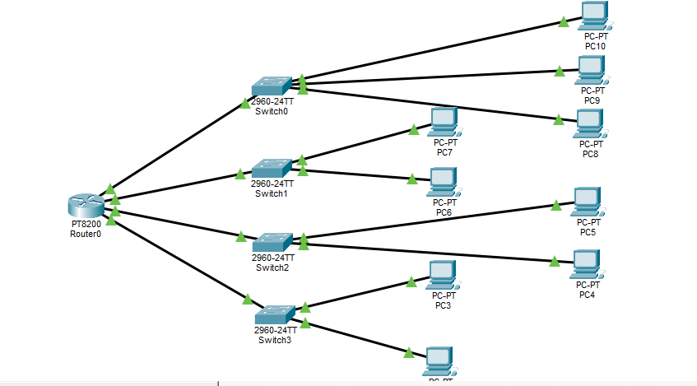

Introduction:
1st connection:
Router -> Switch1: connects from Router GigabitEthernet0/0/0 to Switch1 GigabitEthernet0/1
2nd connection:
Router -> Swithc2: connects from Router GigabitEthernet0/0/1 to Switch2 GigabitEthernet0/1
3rd connection:
Router -> Swithc3: connects from Router GigabitEthernet0/0/2 to Switch3 GigabitEthernet0/1
4th connection:
Router -> Swithc4: connects from Router GigabitEthernet0/0/3 to Switch4 GigabitEthernet0/1

ANALYSIS
Network Address: 176.16.0.0
Subnet Mask: 255.255.192.0
Block Size: 64

Subnet | Network Address | First Host | Last Host | Broadcast
1 | 176.16.0.0 | 176.16.0.1 | 176.16.63.254 | 176.16.63.255
2 | 176.16.64.0 | 176.16.64.1 | 176.16.127.254 | 176.16.127.255
3 | 176.16.128.0 | 176.16.128.1 | 176.16.191.254 | 176.16.191.255
4 | 176.16.192.0 | 176.16.192.1 | 176.16.255.254 | 176.16.255.255

Ip Assignment
Subnet 1 (176.16.0.0/18):
- Router Interface: 176.16.0.1
- PC1: 176.16.0.2
- PC2: 176.16.0.3
- PC3: 176.16.0.4
- Subnet Mask: 255.255.192.0
Subnet 2 (176.16.64.0/18):
- Router Interface: 176.16.64.1
- PC4: 176.16.64.2
- PC5: 176.16.64.3
- PC6: 176.16.64.4
- Subnet Mask: 255.255.192.0
Subnet 3 (176.16.128.0/18):
- Router Interface: 176.16.128.1
- PC7: 176.16.128.2
- PC8: 176.16.128.3
- PC9: 176.16.128.4
- Subnet Mask: 255.255.192.0
Subnet 4 (176.16.192.0/18):
- Router Interface: 176.16.192.1
- PC10: 176.16.192.2
- PC11: 176.16.192.3
- PC12: 176.16.192.4
- Subnet Mask: 255.255.192.0

Router configuration:
interface GigabitEthernet0/0
ip address 176.16.0.1 255.255.192.0
no shutdown
interface GigabitEthernet0/1
ip address 176.16.64.1 255.255.192.0
no shutdown
interface GigabitEthernet0/2
ip address 176.16.128.1 255.255.192.0
no shutdown
interface GigabitEthernet0/3
ip address 176.16.192.1 255.255.192.0
no shutdown

Switch configuration IPs:
Switch | VLAN1 IP | Default Gateway | Connected Subnet
Switch1 | 176.16.0.254 | 176.16.0.1 | Subnet 1 (176.16.0.0/18)
Switch2 | 176.16.64.254 | 176.16.64.1 | Subnet 2 (176.16.64.0/18)
Switch3 | 176.16.128.254 | 176.16.128.1 | Subnet 3 (176.16.128.0/18)
Switch4 | 176.16.192.254 | 176.16.192.1 | Subnet 4 (176.16.192.0/18)

